Daria Pacheco

16 October 2022

COM 301

Assignment 4

1. Given input {4371, 1323, 6173, 4199, 4344, 9679, 1989} and a hash function h(x) = 𝑥 𝑚𝑜𝑑 10, show the resulting:
   1. The items of the hash table are kept in separate linked lists for each index. Using the hash function h(x), it determines the index value (slot) for each element. It moves the new element to the front of the linked list if the linked list at that index is empty. It adds the new element to the end of the linked list if the linked list at that index is not empty (collision). By adding additional members to the hash table, the collision is avoided.

H(4371) = 4371 mod 10 = 1

H(1323) = 1323 mod 10 = 3

H(6173) = 6173 mod 10 = 3

H(4199) = 4199mod 10 = 9

H(4344) = 4344 mod 10 = 4

H(9679) = 9679mod 10 = 9

H(1989) = 1989 mod 10 = 9

H(4371) = 4371 mod 23 = 1

H(1323) = 1323 mod 23 = 12

H(6173) = 6173 mod 23 = 9

H(4199) = 4199mod 23 = 13

H(4344) = 4344 mod 23 = 20

H(9679) = 9679mod 23 =19

H(1989) = 1989 mod 23 = 11

* 1. The new hash function h(x)=x mod 23 is used to determine the index value for every element. If the slot is vacant, the new element is inserted there in the hash table. If that slot is not empty (there has been a collision), it sequentially seeks for an empty slot using the formula (h(x) + f(i)) mod 23, f(i)=i, and i21. By adding additional members to the hash table, the collision is prevented.No collision happened with the new hash function

* 1. Utilizing the new hash function h(x)=x mod 23, it determines the index value for each element. If the space in the hash table is vacant, the new element is inserted there. If the slot is not empty (collision), it uses the quadratic search formula (h(x) + f(i)) mod 23, f(i)=i?, and i21) to look for an empty slot. The collision is prevented by the procedure of adding new elements to the hash table.No collision happened with the new hash function

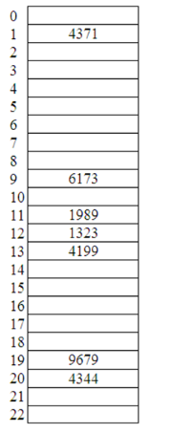

* 1. No collision happened with the new hash function

